**IOT IN TRAFFIC MANAGEMENT**

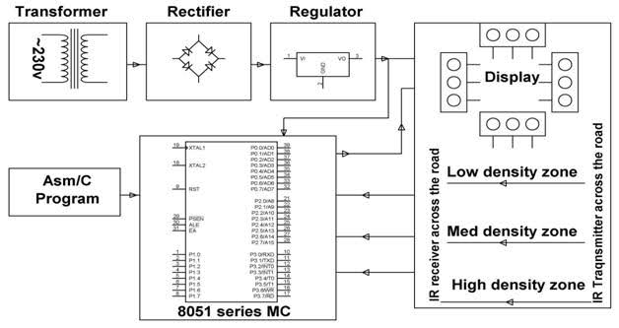

One of the oldest ways of handling traffic was having a traffic policeman deployed at each junction and manually controls the inflow of traffic through hand signaling. However this was quite cumbersome and then came the need for a different type of control – using Traffic signals.

One of the major problems faced in any metro city is traffic congestion. Getting stranded in between heavy traffic is a headache for each and every person driving the vehicle and even to the traffic police in controlling the traffic.

Practically there are two types of Detectors:

Inductive Loop Detector: It consists of a coil of wire embedded into a groove on the road surface which is sealed with a rubber. It detects change in frequency. The inductor coil is connected with the detector which detects the change in resonant frequency of the coil loop and accordingly controls the triggering of the relay which is used to trigger the traffic signals. Basically it works on the principle that when a car moves over the inductor coil, the inductance of the coil decreases. This decreased inductance causes the resonant or oscillation frequency to increase and the electronics unit accordingly sends electric pulses to the control unit to control the switching of traffic lights. However a disadvantage of such system is the inductor loops are prone to electromagnetic interference, i.e. electromagnetic radiation from other devices can also affect the magnetic field and hence the inductance of the coil. They are also more prone to failure and require high installation cost and also cause disruption of traffic.